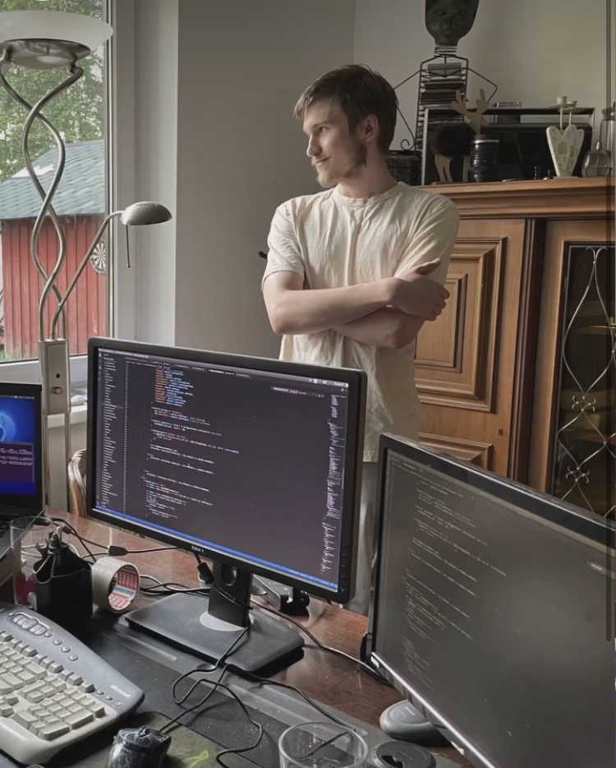

Ēriks Filipovs

Ādaži, Ādaži Municipality, Latvia,
Tel.: +371 27727393,
Age: 25 gadi,
Programming Experience: 10 Gadi
Email: erickdevartworks@gmail.com
Website: https://www.erickdevartworks.com
Projects: https://ionloop.trade/ https://www.business.ionloop.trade/ https://adazi.app

WORK EXPERIENCE

05/2026 – Present Automated Line Packaging Operator;
Ādaži Chips Factory, Orkla Latvia.
Job description: Monitoring packaging processes in accordance with quality standards. Preparing the packaging line for operation; setup, adjustment and maintenance of forming and packaging equipment. Experience with SAP and ERP data-recording systems, as well as ISHIDA and ABB equipment and software.

01/2018 – 12/2019 IT Specialist;
OK Investīcijas, Riga.
Job description: Equipment maintenance and troubleshooting, server-room planning, procurement, ventilation-system installation, and server installation and configuration. Work with Ubuntu 16.04x and Windows Server systems. Operating-system installation according to requirements, network configuration, and preparation of automated system recovery in the event of a power outage.

2009 - 2014 Motorcycle Service Worker;
WBM, Inčukalns.
Job description: organizing and replenishing warehouse stock according to information in the system; cleaning parts using bio-based chemicals; restoration and dismantling work.

ADDITIONAL EXPERIENCE

Property Maintenance;
Ropaži, Ogre, Ādaži, Carnikava
Darba apraksts: Seasonal work, property and grounds maintenance, repair work, and communication with external service providers.

Construction Worker;
Riga, Ādaži, Latvia.
Job description: Interior construction work..

Full Stack Developer (payment, business solutions and trading platform);
IONLOOP.TRADE, Ādaži, Latvia.
Job description: Infrastructure planning and development of the product and multi-platform system without external service providers..

IoT Developer (IoT project development, computer-vision and sensor solutions in a production environment);
Company information unavailable, Ādaži, Latvia.
Job description: System planning and development; creation of computer-vision solutions using image processing and JavaScript only; a system independent of external service providers; ESP32 microcontrollers and VL sensors..

AM, Category B licensed driver;

EDUCATION

2006 – 2015 Ādaži Secondary School;
Ādaži, Latvia; (www.adazuvidusskola.lv)

2015 - 2018 Riga Technical College (IT Specialist);
Riga Technical College; Riga, Latvia; (www.rtk.lv)

LANGUAGES

Latvian Native
English Good proficiency
Russian Intermediate proficiency

TECHNICAL SKILLS

Syntax & Languages:
JS, SH, JSX, TSX... Javascript, C++, Python

Databases:
MongoDB, LevelDB, Redis, MySQL, PostgreSQL, SQLite, experience with SQL and NoSQL

Cloud Platforms:
Google Cloud, Ngrok, Vultr, IBM Cloud, AWS
System Infrastructure:
Cloud-based systems; Raspberry Pi-based distributed networks

AI, LLM & Agent Systems:
LLM integration; architecture of AI agent and multi-agent systems; prompt and agent-role design; model routing; integration of local and cloud LLM solutions; AI workflow automation
AI Infrastructure & Model Hosting:
Preparing Linux servers for AI model hosting; deploying local inference services; GPU/CPU/RAM resource planning; configuring API endpoints and reverse proxies; process management; performance and cost optimization
Testing Tools:
Selenium, Cypress, Playwright, Postman, Bash, Node.js; API, integration, E2E, regression, functional, UI and performance testing; development of test scenarios and acceptance criteria
Payment Systems:
VISA API, MasterCard API, Binance Pay, cryptocurrency integration
Design:
CSS, LESS, CSS3, HTML5

UI Frameworks:
Material-UI, Ant Design (Antd, AntV X6), Bootstrap, Tailwind, React.js, ShadCN, Next.js

Network Protocols:
REST API, WebSockets, JSON-RPC

Security Practices:
DDoS/DoS, phishing, brute-force, malware, SQL injection, XSS, CSRF, authentication and session security, role/access control, 2FA, vulnerability analysis and security testing

ISO & Software Quality Standards:
Practical knowledge of ISO/IEC 27001 information-security management principles, the ISO/IEC 25010 software quality model, ISO/IEC 12207 software life-cycle processes and ISO/IEC/IEEE 29119 testing principles; structuring requirements, risks, testing and technical documentation

Operating Systems:
Raspberry Pi OS, Ubuntu, Windows, Linux, Kali Linux, macOS, iOS

SKILLS

Web interface development
Development of inter-system support and integration layers
Development of internal tools and utilities
Private communication server setup
Database optimization, configuration and management
Design and automation of instance communication networks
Code optimization and code-quality maintenance
Server administration and infrastructure development
Development of work schedules and project timelines
Integration of technical and client security features
Automation of setup, deployment and maintenance processes
Cost and performance-capacity calculation and forecasting
Product architecture design and implementation
Testing and quality assurance
Installation and maintenance of cloud management panels
Creation of complete product documentation, including user instructions, terms, client and company rights, licensing documents (where applicable), legal restrictions, and tax-related submission or reimbursement forms
Gathering and analyzing client requirements and planning technical solutions Communication with clients during project development and implementation Providing technical consultation to clients and users Providing client support and incident-resolution processes Collaboration with development, design and project-management teams Participation in project-planning meetings and task coordination Preparing demonstrations and product presentations for potential clients Training users to work with developed solutions Collecting client feedback and planning product improvements Improving work processes and team efficiency Onboarding new team members into projects and transferring knowledge

PROFESSIONAL QUALITIES

I have gained experience working in a company with around 50 colleagues, communicating effectively with both colleagues and management while maintaining healthy working relationships. At Orkla Latvia, I have worked both at Laima during a production shutdown and independently at Ādaži Chips. I believe I have learned how to build constructive relationships and maintain a positive working environment. I support new employees so they can integrate more easily into a new team and learn in a way that encourages individual growth and development.

I am results-oriented. In a production environment, I set personal goals to become capable of working independently and maintaining production quality even when operating on my own. I aim to understand each process technically so I can optimize equipment operation, extend service life and maintain quality, while identifying shortcomings and proposing solutions where possible.

I also enjoy the programming process. Even when working on complex, data-intensive projects and systems where the codebase exceeds 18 GB, there may be moments when the end is not immediately visible or a solution cannot be found at once. In such situations, rather than trying to hold the entire architecture in my head - for example, when creating an automated load-balancing system without disrupting the project - I can reassess the problem and identify a more direct path to the result.

I value meeting new people and learning new technologies. When exploring new solutions, I am interested in understanding what their developers have built and in contributing my own perspective on opportunities or shortcomings I identify. As a self-taught programmer whose understanding of business and client communication has also been shaped by experienced entrepreneurs, I have developed an understanding of what can be useful to both startups and established companies across multiple industries.

COMPETENCIES

1. Full-Cycle Software Development

Able to independently plan, design, develop, test, deploy and maintain complete web, mobile and desktop systems.

2. Full-Stack Development

Experience developing client-side and server-side solutions using JavaScript, TypeScript, React, Next.js, Node.js, REST APIs, WebSockets and databases.

3. System Architecture Design

Able to design scalable product architecture, divide systems into modules, and plan data flows, integrations, security and infrastructure.

4. Artificial Intelligence Solution Integration
Able to integrate AI models into business processes, user systems, data analysis, document processing, customer service and automation.

5. Traditional & AI Automation

I build automated processes using both traditional programming solutions and AI agents, reducing manual work and accelerating day-to-day operations.

6. Growth & Development Capabilities
Able to analyze products, identify growth opportunities, develop user acquisition and retention strategies, and improve conversion and product usage.

7. LLM & AI Agent System Development
Able to design and use LLM-based agent and multi-agent systems for software development and business-process automation, defining agent roles, task allocation, quality-control stages and model routing.

8. Cybersecurity Solutions
Knowledge of web and infrastructure security risks, including DDoS, DoS, phishing, brute-force attacks, malware, SQL injection and XSS vulnerabilities.

9. Secure Authentication & Access Systems
Able to implement user authentication, role and access control, two-factor authentication, PIN and QR authorization, and secure session management.

10. Computer Vision Solution Development
I develop computer-vision systems for detecting and analyzing objects, colors, boundaries, vehicles, road zones and production processes.

11. AI Model Hosting & Infrastructure
Able to prepare and administer Linux server environments for running AI/LLM models, plan CPU, GPU and RAM resources, deploy inference services and APIs, configure reverse proxies and process management, and analyze performance and infrastructure costs.

12. Software Testing & Quality Assurance
Experience in functional, API, integration, E2E, regression, UI and performance testing using Selenium, Cypress, Playwright and Postman, as well as developing test scenarios, acceptance criteria and quality-control processes.

13. ISO Standards in Software Development
Knowledge of ISO/IEC principles relevant to software development, quality, testing and information security, including ISO/IEC 27001, ISO/IEC 25010, ISO/IEC 12207 and ISO/IEC/IEEE 29119, with the ability to apply them when structuring requirements, risks, testing and documentation.

14. Security Testing & Secure System Design
Able to analyze web and infrastructure attack surfaces, test authentication, authorization, session and input-validation mechanisms, identify common vulnerabilities and implement protective measures.

